https://github.com/tuskauavproject

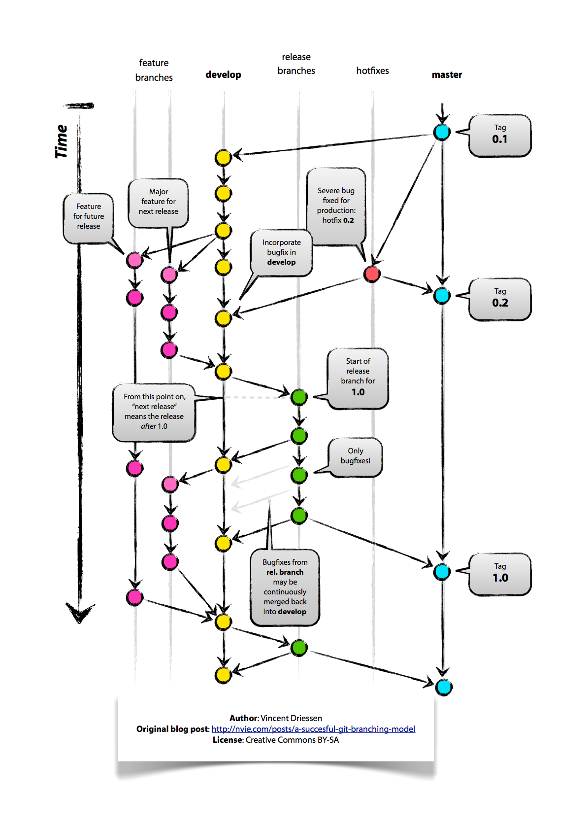
- Create an account on Github using your crimson email. Use mybamausername-tuska (arlarson-tuska) and visit the link above.
- Download Github for windows https://windows.github.com or mac https://mac.github.com

